Title or Task: | Test for Photoshop APS108 Exam  
Description: | Correct images to create a new post production image
Files Required | APS108 post prod instructions.jpg  APS108 post prod one.jpg  APS108 post-prod-two.jpg
Suitable for Classes: | AIT • Multimedia • Cert II IT • Cert II Bus
Area: | Technology & Enterprise
Teacher: | Mr Peter Faulks
Timeline | 1 or 2 lessons
Date Due: | By end of week
Task Brief: | Working with various Photoshop techniques
Outcomes: | Technical ability - advanced

Items highlighted in yellow are tasks for you to complete
Items in Blue italics are help tips

APS108 Post Production Test (In class)

Type your name here:

Save this document as
surname postproduction.doc (surname = your surname)

You often will have work to create a finished product after all the work has been undertaken, In photography we use Photoshop and the industry standard so here is a short Exersize in Photoshop. Here we have two girls with background elements that we need to clean up.

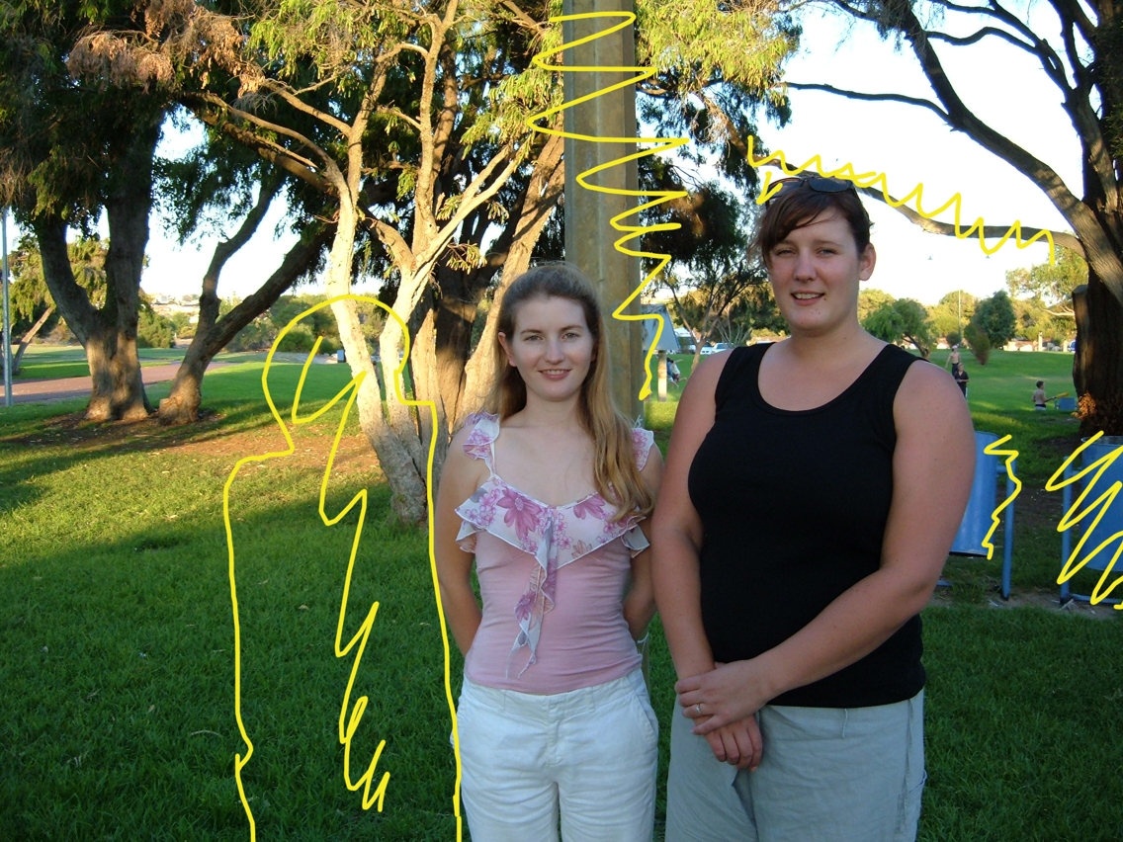

We need to use Photoshop and the clone tool to remove the bins and the light pole and all the stuff in yellow. On the left of the pink girl we need to add her friend so that it looks like the three girls were together.

Using the visual instructions place one girl with a photo of two girls to create an image on three girls – elements drawn show where image must be manipulated after production

Open the following files
APS108 post prod instructions.jpg
APS108 post prod one.jpg
APS108 post-prod-two.jpg

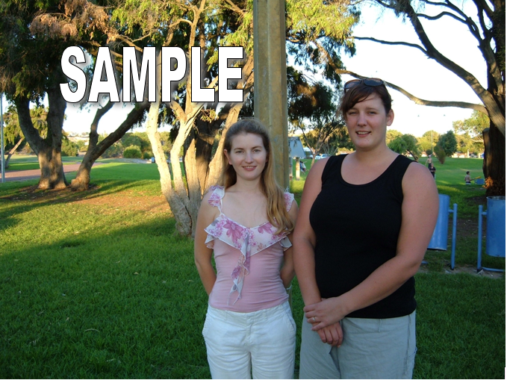

Make changes as shown(yellow squiggles) in the instructions for Two Girls


Use Photoshop Lasso Tool, Filters Extract and Clone Tool

Once you have saved a NEW copy of the work as Postproduction1.jpg

Open and Start work on the APS108 post prod one.jpg

Save this as surname Postproduction2.jpg (surname = your surname)

Paste screenshots here:
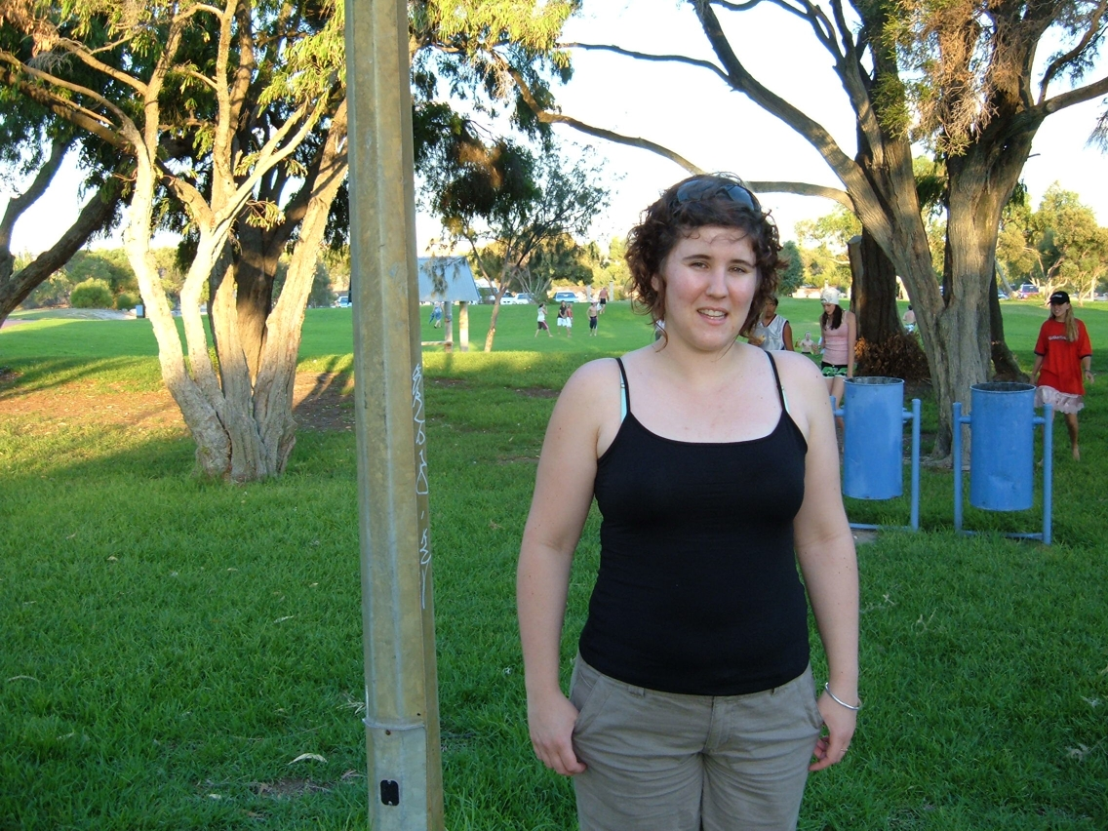
One Girl

Final (Should look something like this)
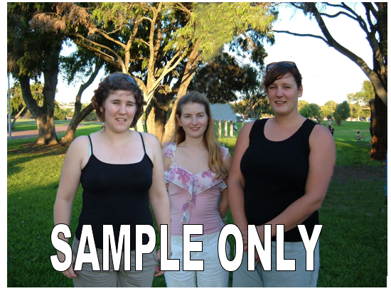

Paste your screenshots here:

If you want an extra mark paste your girls onto a new background


